# Task 7 Documentation

Test Parameters:

* Think time: 700 [ms]
* Max Number of Users: 15
* Ramp-up period: 1600 [s]
* Duration: 1800 [s]

Capacity Testing Results:  
  
Based on the chart we can assume system can handle around 12 users. Just before reaching 15 threads application fully stopped working.  
  
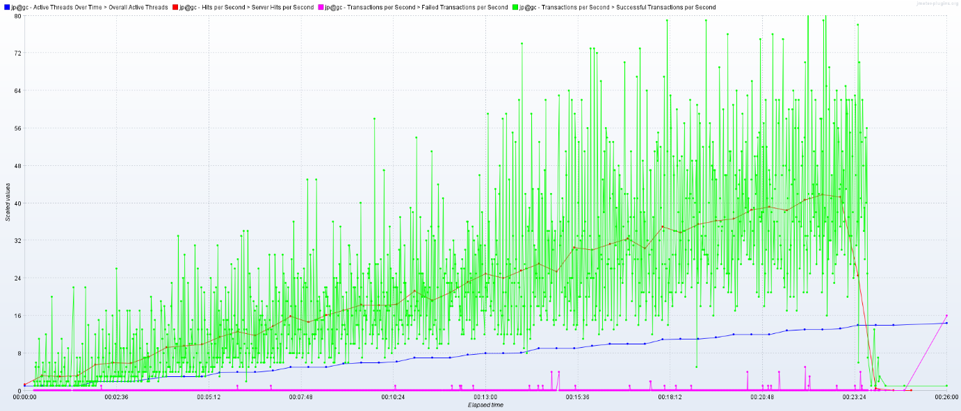  
  
From diagram we can see from time to time server returned errors from time to time.  
The most error prone transaction are:

Create User: 2.12 % of errors (admin flow)  
Add Comment: 1.32 % of errors (anonymous flow)  
Open Post: 1.07 % of errors (anonymous flow)